**VIDYALANKAR INSTITUTUTE OF TECHNOLOGY**

(Affiliated to University of Mumbai)

Wadala(E), Mumbai - 37



A MINI-PROJECT REPORT

ON

**HOTEL MANAGEMENT**

(Course – Internet Programming Lab)

Submitted by

**STUDENT NAME**

Shravan Kegade (17101B0052)

Abhishek Singh (17101B0061)

Prachi Gujar (17101B0048)

# **Department of Information Technology VIT,**

# **Wadala(E), Mumbai-37**

2019-2020

**VIDYALANKAR INSTITUTUTE OF TECHNOLOGY**

**Department of Information Technology**

**VIT, Wadala(E), Mumbai-37**

# 

# CERTIFICATE

Certified that the mini-project work entitled **“ HOTEL MANAGEMENT”** is a bonafide work carried out by

**STUDENT NAME ROLL NO**

Shravan Kegade 17101B0052

Abhishek Singh 17101B0061

Prachi Gujar 17101B0048

The report has been approved as it satisfies the academic requirements in respect of mini project work prescribed for the **course- Internet Programming Lab**.

…………………

**Ms. Harshali Rambade**

Faculty In-Charge

………………… …………………

**Internal Examiner External Examiner**

**TABLE OF CONTENT**

**Module 1 Introduction**

1.1Problem Statement

1.2 Need of the Project

1.3 Scope

**Module 2 Characteristics Of Project**

**Module 3 Description**

3.1 Client side

3.2 Sever side

3.3 Database

**Module 4 Hardware and Software Requirements**

**Module 5 Screenshot of Websites**

**References**

**Module 1**

**Introduction**

* 1. **Problem Statement**

We have built a website of a hotel. There are many websites already available on internet, what makes our website different from other websites is that most of them provide unnecessary data which is irrelevant and not always needed by a customer. Such information may lead to wastage of time. Our site provides you with direct information and all the relevant things which is a basic need of a customer when he/she will access it.

**1.2 Need of the Project**

In our project we have tried to simplify the need of common people regarding the knowledge about a particular restaurant .We made it easier for the consumers to get the basic knowledge regarding the place. For the purpose of contact and making reservations , we created a simple website about a restaurant which was put into execution.

* 1. **Scope**
* Guests can book seats as per their requirement without any pre-booking charges .
* They can get their queries resolved quickly by communicating with us using the contact us section.
* They get to know what is the available menu and accordingly they can plan their way to the hotel.
* We also arrange birthday parties, wedding ceremonies, engagement ceremonies, provide hospitality to various events in school, colleges, etc. So once they have been our customers they are eligible for a discount if they are giving us an opportunity to serve in the above mentioned events.

**Module 2**

**Characteristics Of Project**

* It is observed that use to search for a hotel using their phones so it was necessary that the website was responsive one so that the user would not have any problem surfing it.
* It was necessary to display real images and the available menu only for avoiding the chaos when the user visits our hotel. Google map location was required so as to cut the problem of finding the hotel.
* Along with the website customers need to be updated with social media platforms, so social media platforms were necessary to be created.

**Module 3**

**Description**

* 1. **Client Side**
* At client side we present you with best user experience.
* First, the home page where we have presented the website with some image slideshow along with book a table option which directs the user to the reservation page.
* Slideshow gives you an overview of different speciality of our hotel so that it becomes easier for choosing the special dish. Google Maps in our page makes your task easier for locating our hotel. At the end contact us, where you can easily ask your doubts to us.
* Secondly the about us page gives the customers an idea about what all activities we conduct.
* Followed by counter where we have displayed the total count of menu we serve, total events organised and total members served.
* Menu gives a clear idea of what is available in a particular section.
* Reservation gives the users a platform to book their seats followed by a gallery which shows the pictures of the dishes.
* Finally, you can contact us if you have any query.

**3.2 Server Side**

On server side we used CSS for modification, animation and refining the site to a further extent. JavaScript is used for providing action on particular button. Every action or alert is given or executed via JavaScript. PHP is used for database part, the data which you enter on search bar and booking page will be stored using PHP. Basically, all the detail of a user is stored using PHP.

**3.3 Database**

Database is linked to the search bar where we have applied php, MySQL. Booking page contains database linked to it which is helpful at the server end. Database stores result after booking is done.

**Module 4**

**Hardware and Software Requirement**

**Software**

XAMPP:-

XAMPP is a free and open-source cross-platform web server solution stack package developed by Apache Friends, consisting mainly of the Apache HTTP Server, MariaDB database, and interpreters for scripts written in the PHP and Perl programming languages.

EDITOR:-

The Visual Studio integrated development environment is a creative launching pad that you can use to edit, debug, and build code, and then publish an app. An integrated development environment (IDE) is a feature-rich program that can be used for many aspects of software development.

**Hardware**

WINDOWS:-

Windows 10 technical preview has these requirements:

* Processor: 1 gigahertz (GHz) or faster.
* RAM: 1 gigabyte (GB) (32-bit) or 2 GB (64-bit)
* Free hard disk space: 16 GB.
* Graphics card: Microsoft DirectX 9 graphics device with WDDM driver.
* A Microsoft account and Internet access.

PC/Laptop:-

Most people associate a [personal computer (PC)](https://www.webopedia.com/TERM/P/personal_computer.html) with the phrase computer.  A PC is a small and relatively inexpensive computer designed for an individual use. PCs are based on the microprocessor technology that enables manufacturers to put an entire [CPU](https://www.webopedia.com/TERM/C/CPU.html) on one chip.

Personal computers at home can be used for a number of different applications including games, word processing, accounting and other tasks.

Computers are generally classified by size and power as follows, although there is considerable overlap. The differences between computer classifications generally get smaller as technology advances, creating smaller and more powerful and cost-friendly components.

• [**Personal computer**](https://www.webopedia.com/TERM/P/personal_computer.html)**:** a small, single-user computer based on a microprocessor. In addition to the microprocessor, a personal computer has a keyboard for entering data, a monitor for displaying information, and a storage device for saving data.

• [**Workstation**](https://www.webopedia.com/TERM/W/workstation.html)**:** a powerful, single-user computer. A workstation is like a personal computer, but it has a more powerful microprocessor and a higher-quality monitor.

• [**Minicomputer**](https://www.webopedia.com/TERM/M/minicomputer.html)**:** a multi-user computer capable of supporting from 10 to hundreds of users simultaneously.

• [**Mainframe**](https://www.webopedia.com/TERM/M/mainframe.html)**:** a powerful multi-user computer capable of supporting many hundreds or thousands of users simultaneously.

• [**Supercomputer**](https://www.webopedia.com/TERM/S/supercomputer.html)**:** an extremely fast computer that can perform hundreds of millions of instructions per second.

**MODULE 5**

**Screenshot of Website**

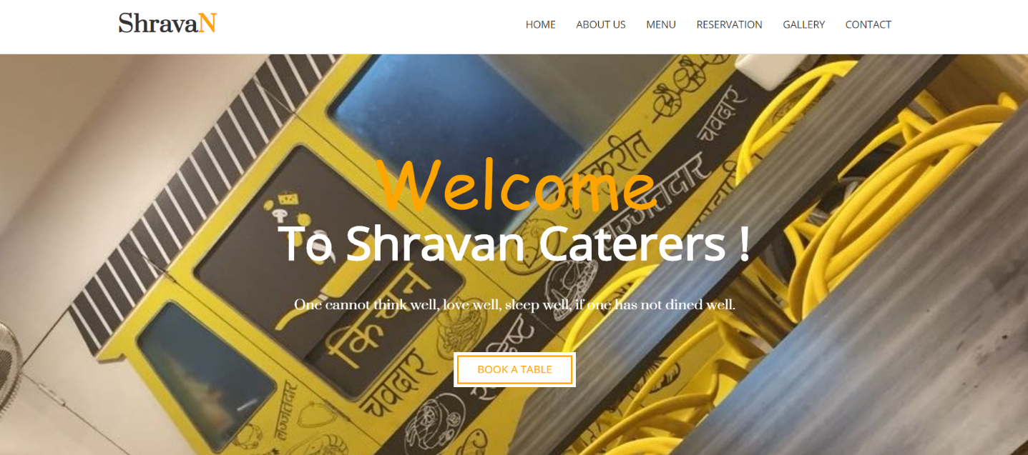

**Home Page**

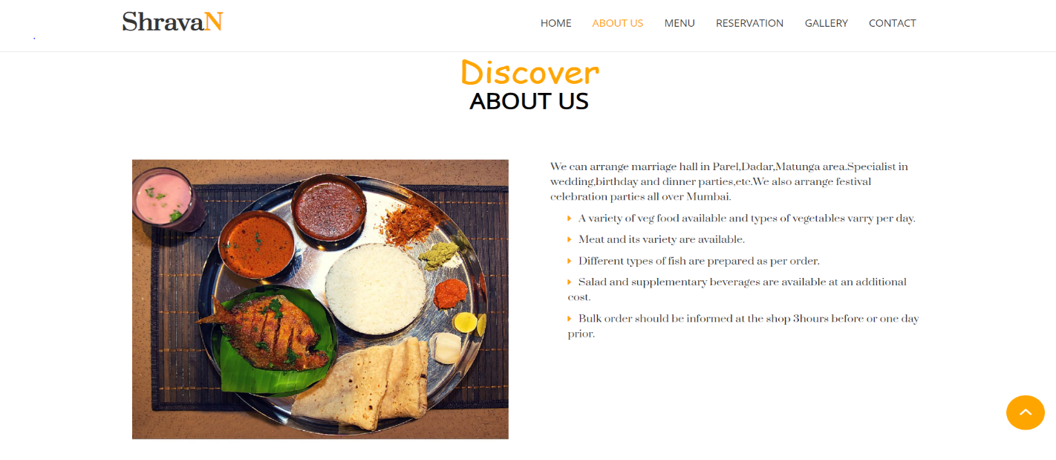

**About Us**

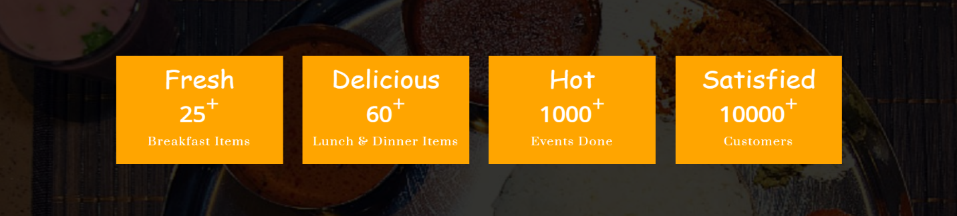

**Counter Section**

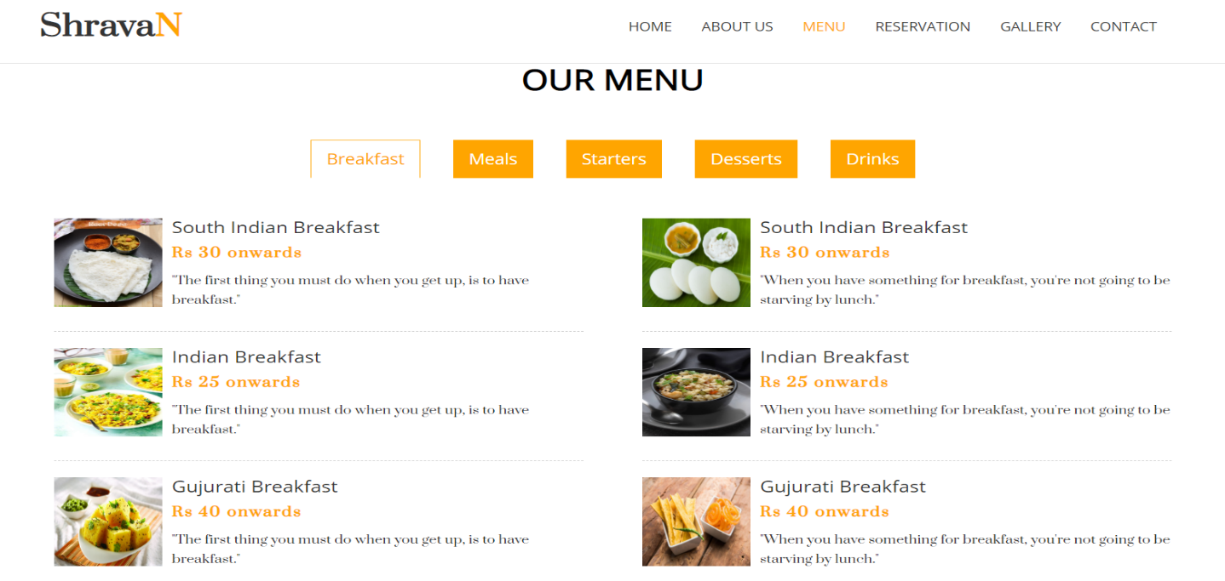**Menu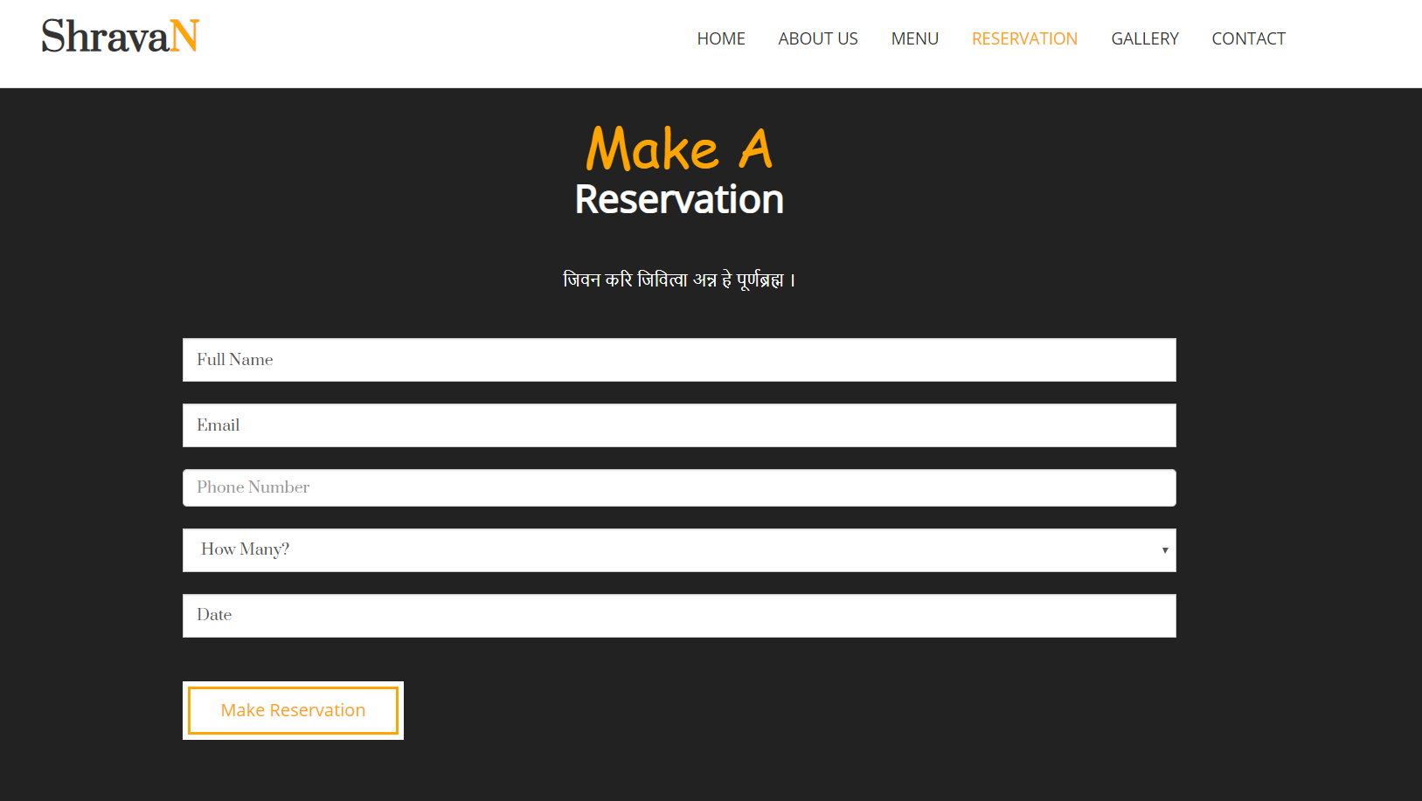Reservation Form**

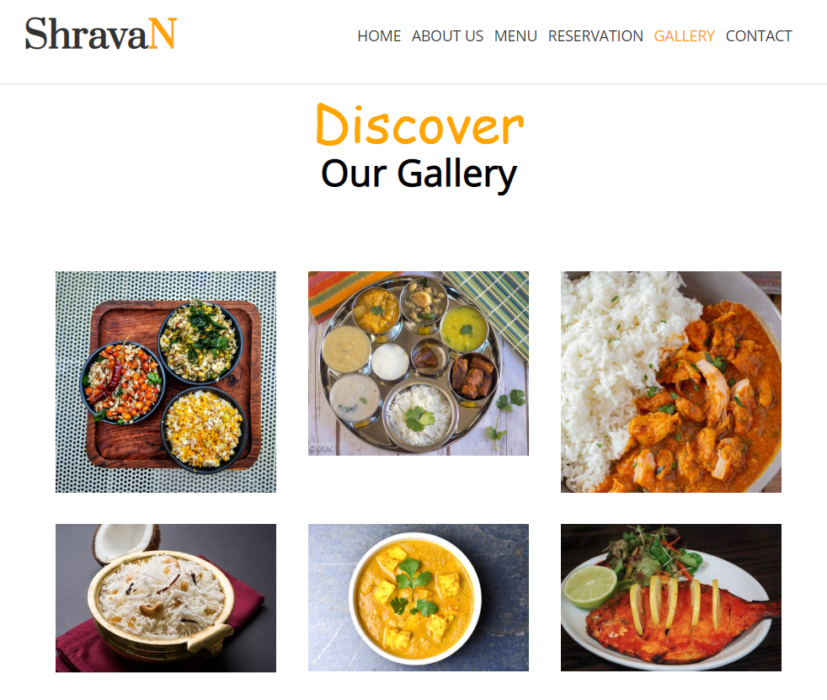

**Gallery Photos**

**Testimonial**

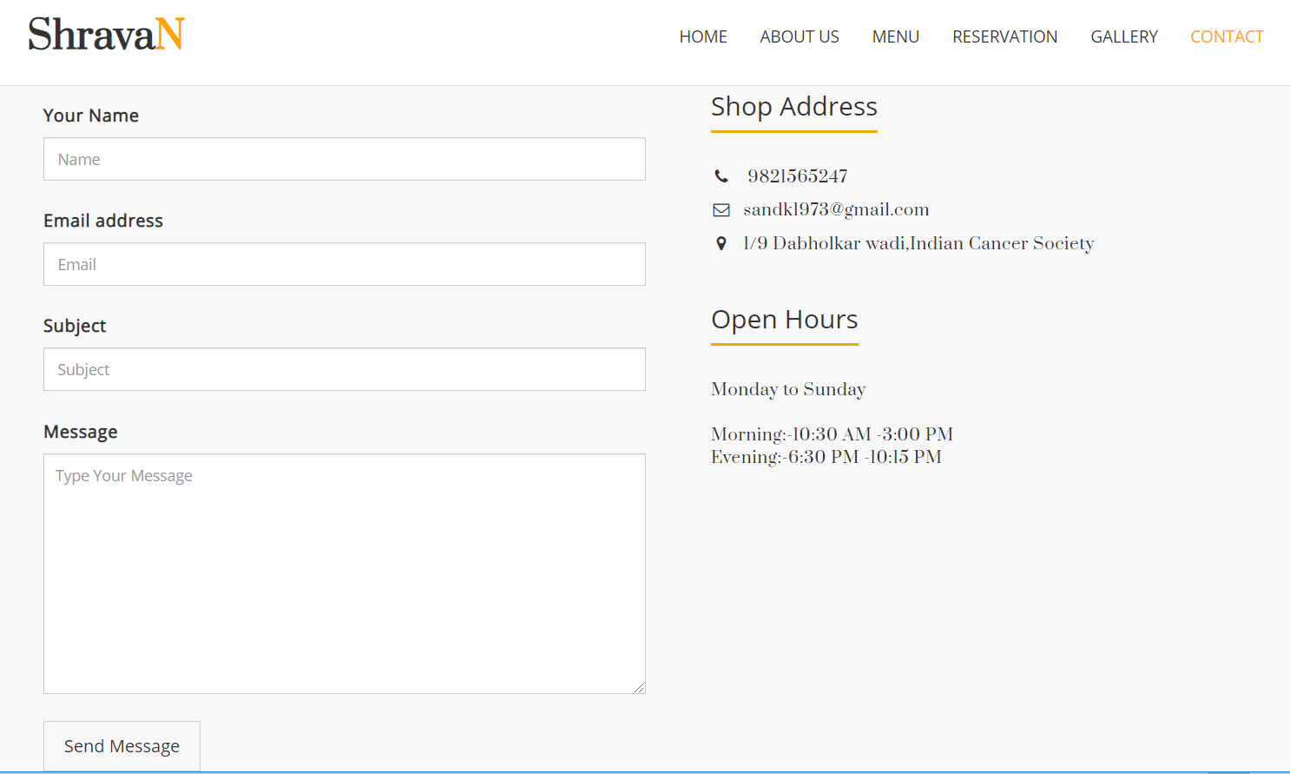

**Contact Form**

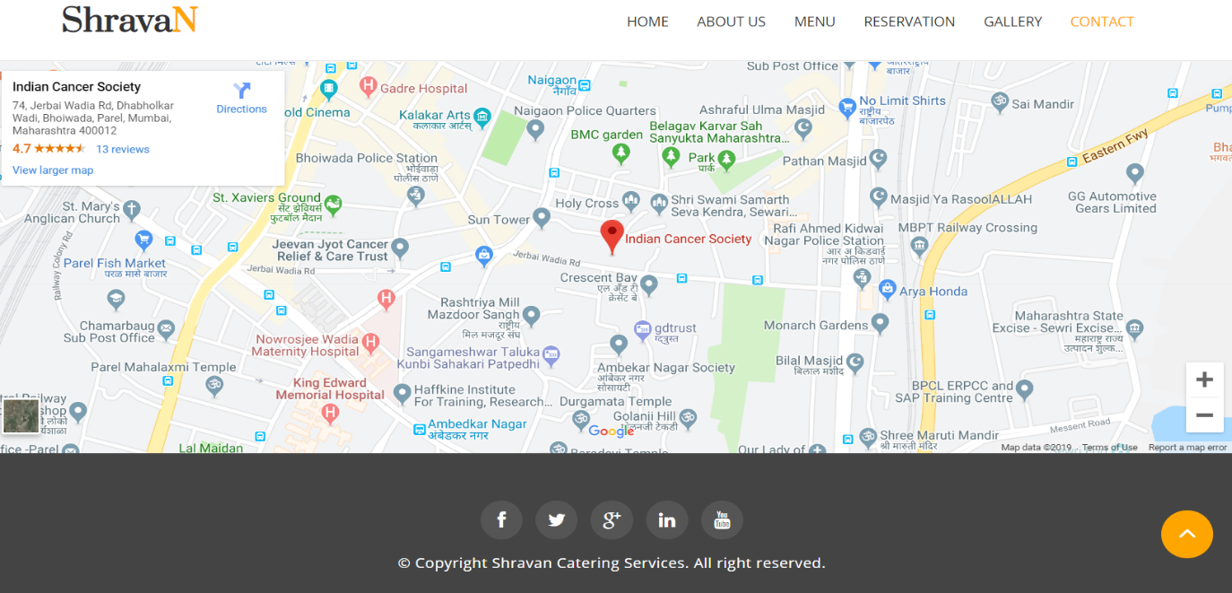

**Google Location**

**References**

[1] Café 21 (<http://www.cafebar21.fi/>)

[2] Gala Caterers (<http://www.galacaterers.in/>)

[3] W3Schools (<https://www.w3schools.com/>)

[4] CodePen (<https://codepen.io/>)

[5] Stack Overflow([https://stackoverflow.com](https://stackoverflow.com/))